Release Assembly - TC Cockpit Start Project Flow Billing Account Integration Deployment Guide

Revision History
Author | Revision Number | Date
TCSASSEMBLER | 1.0 | 4/19th/2013

Deployment Instructions 3
1. Organization of Submission 3
2. Application Setup 3
2.1 Ant .Properties File 3
2.2 Configurations 3
2.3 Build Scripts Setup 3
3. Database Setup 4
4. Deployment Instructions 4
5. Starting 4
6. Verification 4
6.1 Before starting verification 4
6.2 Verification steps 4
7. Resource Contact List 11

Deployment Instructions

Organization of Submission

The submission follows directory structure provided below:

doc
Contains the Deployment Guide Document of this assembly.

direct
Contains sources and static files for Direct web application and the Direct backend components. This directory replicates the application development distribution structure and includes only updated and new files.
test_files
Contains the SQL files to insert test data

Application Setup

The application is expected to be deployed to the following environment:

JRE 1.5
JBoss 4.2.3.GA
Informix DS 11.5

Ant .Properties File

Configurations

N/A

Build Scripts Setup
The ANT build script for Direct application (build.xml) provides the following targets which are to be used:

- switch-and-checkout – checkout or switch to the defined source code branches for all components defined in subprojects.xml
- dist-backend – rebuilt all the components from the source code.
- first_deploy – must be the first task to execute from command line. It will copy all dependencies to your local JBoss folder.
- deploy – should be the main task to execute from command line. It will build and deploy WAR file.
- deploy-static-files – deploys the static files to JBOSS.
- deploy-apache-static – deploys the static files to apache server on VM.

Please refer here for more information:
http://www.topcoder.com/wiki/display/docs/TC+Direct+Setup+Guide

Database Setup
N/A

Deployment Instructions

This section provides the instructions in Production environment.

- Merge the code from submission into SVN for Direct application including the backend components project service façade and project service
- Run ant dist-backend to rebuild all the backend components
- Build and deploy Direct application using ant deploy (or ant first_deploy ) command.
- Copy static files using ant deploy-static-files command or ant deploy-apache-static if use apache as static file server.

Starting

- Build and deploy the Direct application
- Start JBoss server instance hosting Direct application

Verification

Before starting verification
Set up test data first, run the following SQL scripts in order against the test server database:
- test_files/test_data.sql

Use various browsers to open the link http://localhost:8180/direct or https://[vm_ip]/direct/ , login as user / password.

Verification steps

Create new project with billing account set

Click “Start a Project” button on the right sidebar

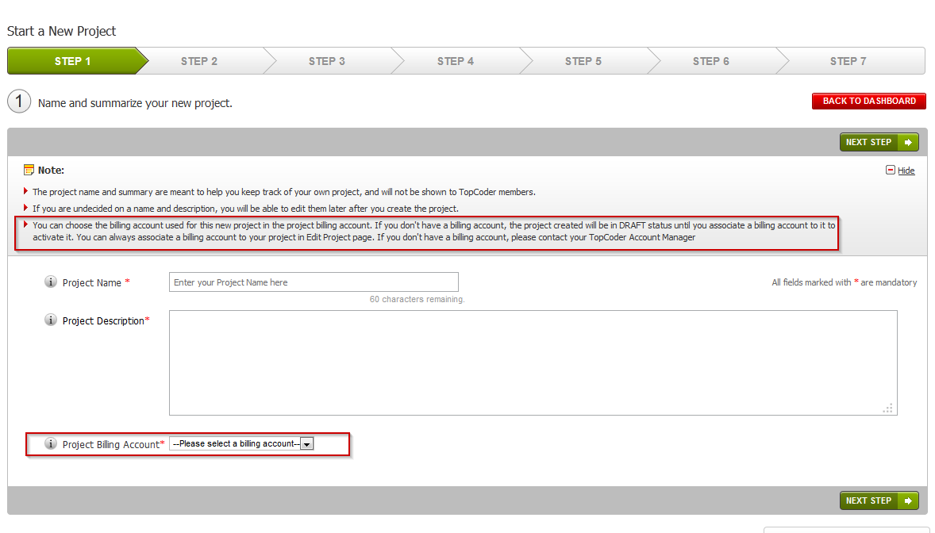

Click next step

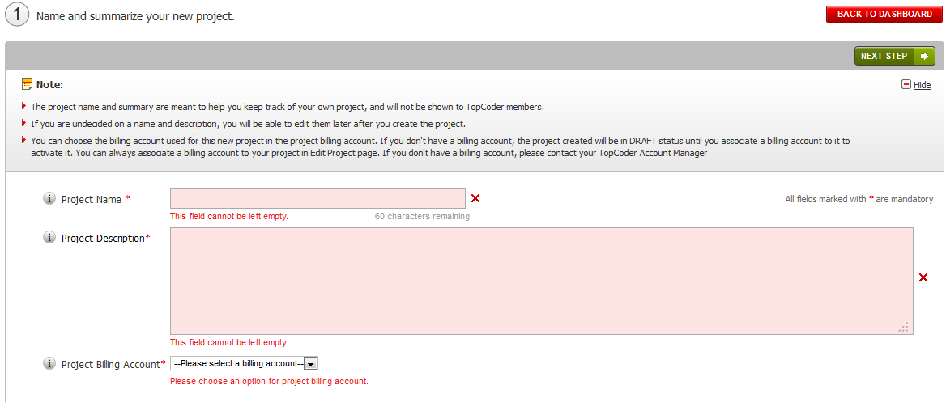

See project billing account options

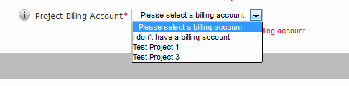
Set project name, project description and choose a project billing account

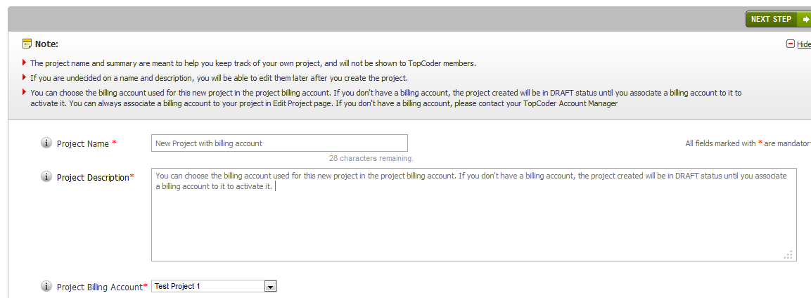

Click next steps to create, remember to choose create copilot posting in step 4

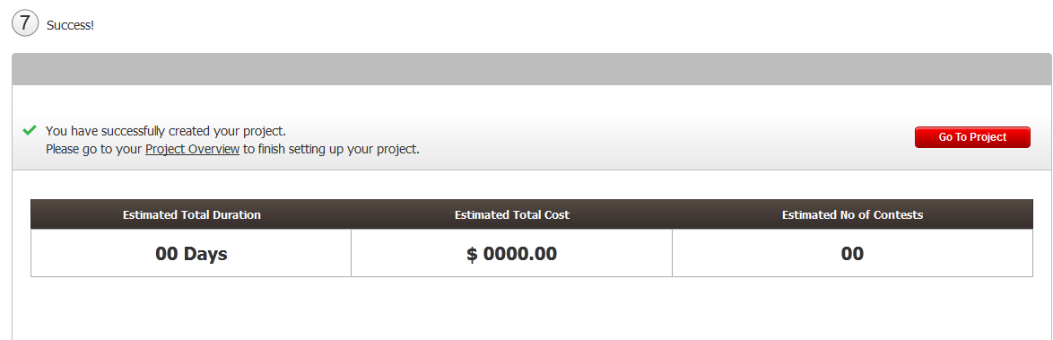

Go to project overview page

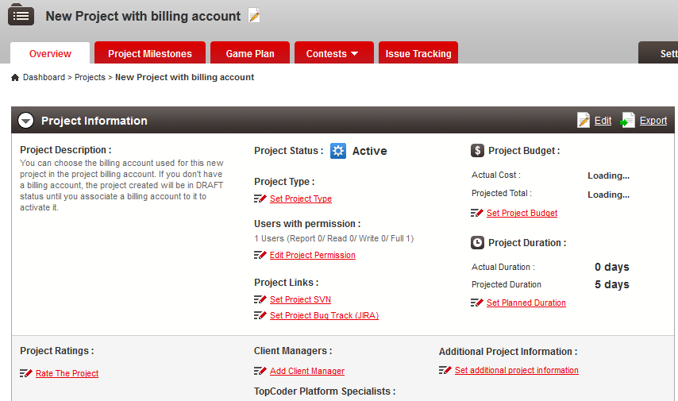

The project status is active

Go to edit project page

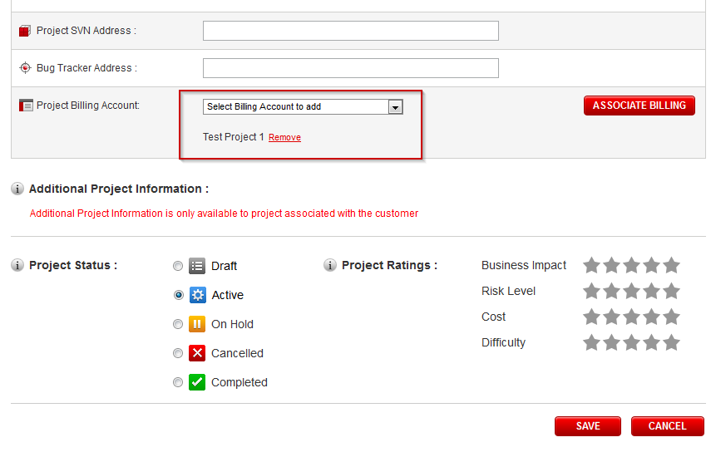

The billing account has already been added

Go the checking copilot posting

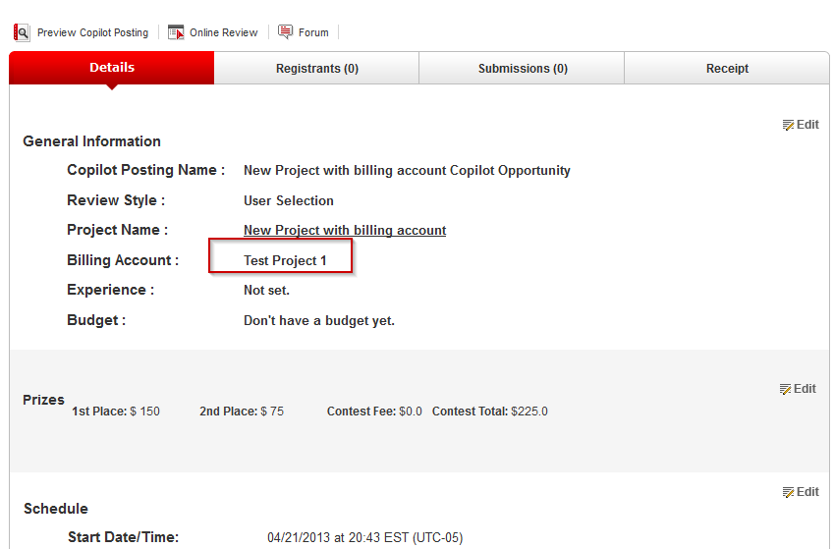

The copilot posting is created with the project billing account.

Create new project without billing account set

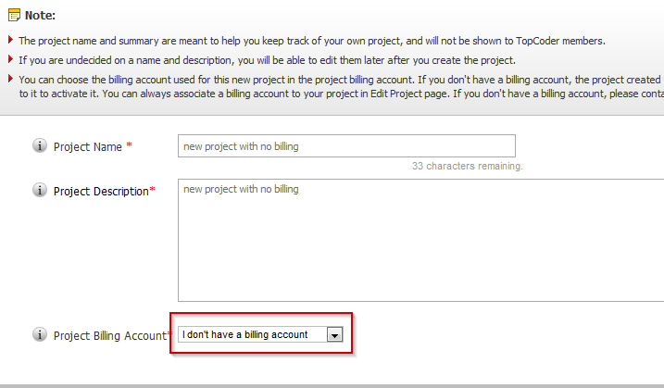

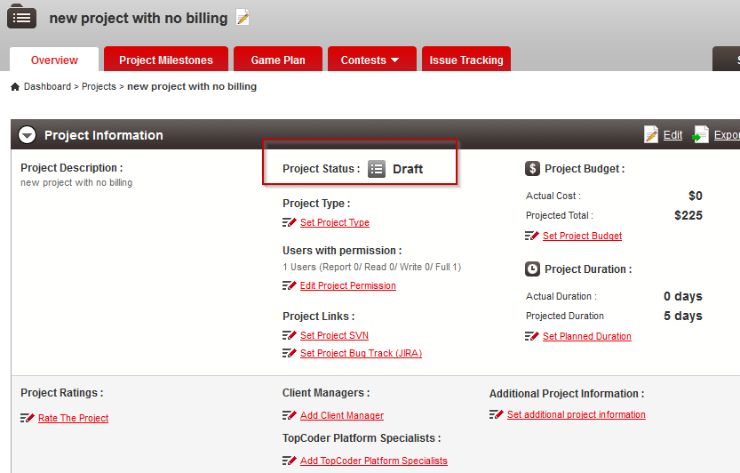

Edit project page updates

Go to edit project page to activate the draft contest, change status to active and click save

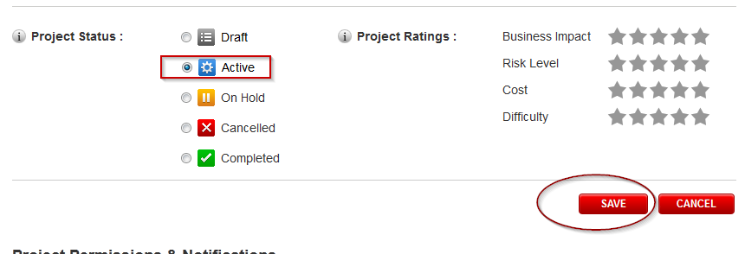

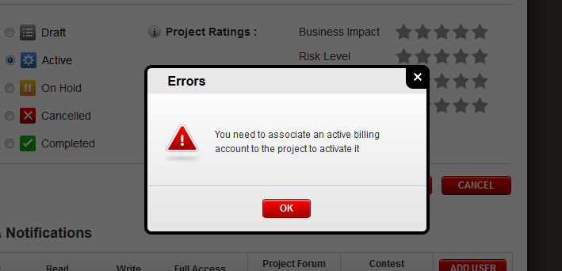

Error message should be shown

Add a billing account to the project

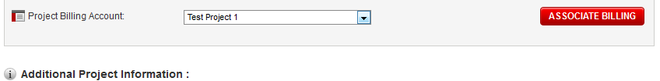

Click associate

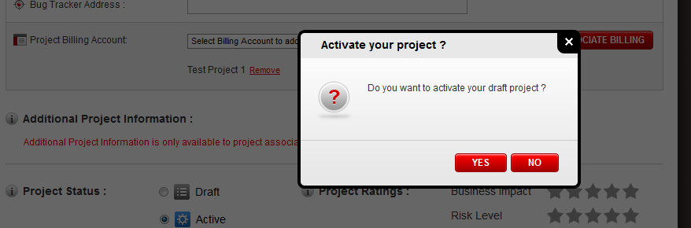

Click Yes

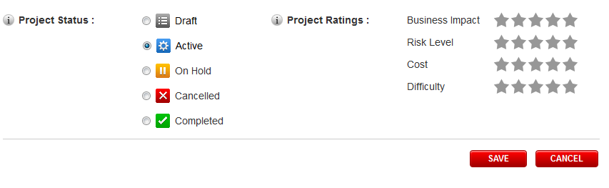

The project is activated.

Resource Contact List

Name | Resource Email
TCSASSEMBLER

